**Here’s the Reality About Illegal Immigrants in the United States**

*New York Times* - By Vivian Yee and Kenan Davis and Jugal K. Patel – March 6, 2017

There are 11 million of them, the best estimates say, laboring in American fields, atop half-built towers and in restaurant kitchens, and swelling American classrooms, detention centers and immigration courts.

In the public’s mind, the undocumented — the people living here without permission from the American government — are Hispanic, mostly Mexican and crossed the southwestern border in secret.

In the eyes of their advocates, they are families and workers, taking the jobs nobody else wants, staying out of trouble, here only to earn their way to better, safer lives for themselves and their children.

At the White House, they are pariahs, criminals who menace American neighborhoods, take American jobs, sap American resources and exploit American generosity: They are people who should be, and will be, expelled.

Illegal immigrants can be many of these things, and more. Eleven million allows for considerable range, crosshatched with contradictions.

There may be no more powerful symbol of how fixedly Americans associate illegal immigration with Mexico than the wall President Trump has proposed building along the southern border. But many of the unauthorized are not Mexican; almost a quarter are not even Hispanic.

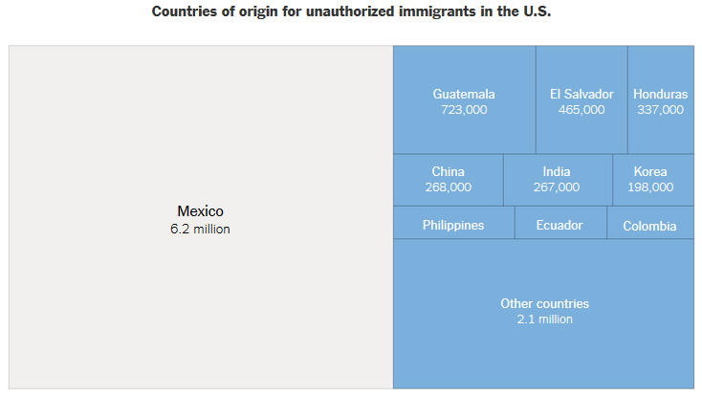

After Mexico, Guatemala, El Salvador and Honduras, the largest number of unauthorized immigrants comes from China (an estimated 268,000), where deportations run aground on a less literal wall: China is one of 23 countries that do not cooperate with deportations. (The Trump administration has pledged to pressure all 23 into doing so.)

They tend to be younger — the Pew Research Center has found that adult unauthorized immigrants were, at the median, about a decade younger than American-born adults — and skew slightly more male than the rest of the country.

Geography and demography are only two ways to anatomize these 11 million. Circumstance offers another: As he seeks to tighten law enforcement’s grip on unauthorized immigrants, Mr. Trump will grapple with a population of people who arrived in several ways and for myriad reasons, each slice presenting its own challenges.

To hear many liberals and immigrant advocates tell it, most undocumented immigrants are productive, law-abiding members of society, deeply rooted in communities all over the country, working hard, living quietly, paying taxes and raising families.

Statistics show that many of the undocumented fit this profile. **About 60 percent of the unauthorized population has been here for at least a decade**, according to the nonpartisan [Migration Policy Institute](http://www.migrationpolicy.org/?gclid=COuNgrCOrNICFZCFswod2NoLYQ).

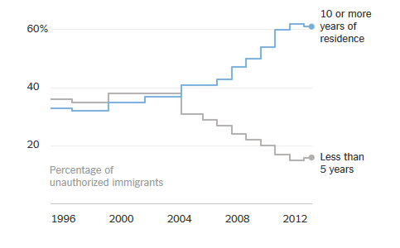A third of undocumented immigrants 15 and older lives with at least one child who is a United States citizen by birth. Slightly more than 30 percent own homes. Only a tiny fraction has been convicted of felonies or serious misdemeanors.

Of course, as the Trump administration has emphasized, merely being here without authorization is a violation of the law.

Even the wording of the issue is revealing: conservatives favor the term "illegal immigrants," which hardliners often truncate to "illegals"; immigrant advocates prefer "undocumented immigrants," a phrasing that they say prods the conversation back toward the humans in question, but that also has a whiff of euphemism. "Unauthorized" often shows up as a neutral alternative.

No matter the label placed on them, people like Lydia, 47, who runs a small jewelry store in Los Angeles, do not think of themselves as lawbreakers.

Lydia, who like several undocumented immigrants did not want her last name published for fear of being deported, crossed the border through Tijuana in 1988. She looked for legal help from a notary, mistakenly thinking that a “notario” indicates a legal expert, as it does in many Latin American countries.

She was eventually ordered out of the country. But the Obama administration deprioritized deportations of people who had committed no major crimes, and it allowed her to live and work in the United States as long as she checked in with an immigration agent each year.

Lydia raised four children, all citizens, and sent them to public schools in Sun Valley, a suburb north of Los Angeles. She and her husband bought a home there, paid off their mortgage and bought a second home nearby.

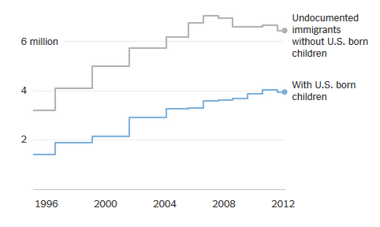

Now she is a candidate for deportation once again, and is anxious each time she steps out of her home.

“I am in limbo,” she said. “I am afraid I will go out and never come back.”

**Criminal Records**

Few nemeses loomed larger in the narrative of Mr. Trump’s presidential campaign than the figure of the illegal immigrant who threatened Americans — one of the “rapists” and “killers” from Mexico, as Mr. Trump has put it.

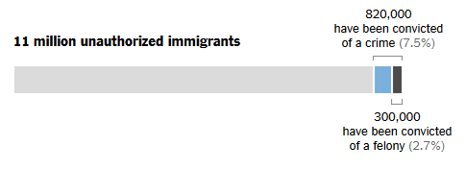

Such people do exist. The Migration Policy Institute has estimated that 820,000 of the 11 million unauthorized have been convicted of a crime. About 300,000, or less than 3 percent of the 11 million undocumented, have committed felonies. (The proportion of felons in the overall population was an estimated 6 percent in 2010, according to a paper presented to the Population Association of America.)

Immigration agents regularly arrest what the government calls “criminal aliens.”

At the end of January, [agents arrested](https://www.ice.gov/news/releases/ice-milwaukee-arrests-16-during-operation-targeting-criminal-aliens) a 50-year-old Mexican man near Milwaukee who had felony convictions for assault with a deadly weapon, battery against a police officer, car theft and intentionally harming a child, and who had been deported twice before. Last week, they caught an undocumented Honduran man in North Carolina, Francisco Escobar-Orellana, who is wanted in Honduras for allegedly [hacking two men to death](https://www.ice.gov/news/releases/ice-arrests-honduran-fugitive-wanted-machete-murders-2-men) with a machete in 1993.

The Trump administration has said it will continue to prioritize deporting those with serious criminal records, but, in a break from the Obama administration, the new policies also take aim at immigrants whose offenses are limited to living here without permission or minor crimes that enable immigrants to work here, like driving without a license or using a fake Social Security number.

The Social Security Administration estimated that in 2010, 1.8 million undocumented immigrants worked under a number that did not match their name.

Surrounded by the sugar cane fields of Clewiston, Fla., working backbreaking jobs, Maria and Benjamin took pains to follow the rules, pay taxes and stay out of the way. But now they fear the one rule Benjamin had to break to survive — he used a fraudulent Social Security number to secure a job — may prove their undoing.

Benjamin, 42, fixes the hydraulic trucks used for the area’s cane-cutting operation, which means he works 17 hours a day, often at night.

“This worries us, but we don’t have an option,” said Maria, 38, who arrived from Mexico when she was 19. “He has always worked and has always had a fake Social Security card. That is the way you get a job.”

**Overstayed Their Visas**

Some people endure long journeys by foot, train, boat and smugglers to make it across the border. But for an increasing number of immigrants, illegal status arrives overnight, without a single step.

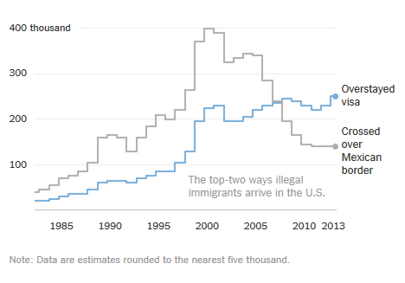

In each year from 2007 to 2014, more people joined the ranks of the illegal by remaining in the United States after their temporary visitor permits expired than by creeping across the Mexican border, according to a [report by researchers at the Center for Migration Studies](http://cmsny.org/publications/jmhs-visa-overstays-border-wall/).

A partial government estimate released last year said that 416,500 people whose business or tourist visas had expired in 2015 were still in the country in 2016. That does not count people who came here on student visas or temporary worker permits.

Numbers like these have convinced some conservatives that the federal government needs to worry more about people who abuse their temporary legal status than about border security.

In 2005, tourist visas brought Wei Lee and his parents to San Francisco from Brazil, where Mr. Lee’s parents, who had emigrated from China, ran a restaurant outside São Paulo. They remained in the United States after the visas expired.

After being mugged and beaten in 2013, Mr. Lee recently received a U visa, which is reserved for victims of crime. His parents, however, are still undocumented.

“Some people misunderstand, they think people come here and overstay their visas intentionally, but there are all these push and pull factors,” said Mr. Lee, 28, a college graduate who now works with Asian undocumented youth. “My parents had to make a decision for their lives.”

After the expiration of the tourist visa that Rebeca, a former television reporter from Venezuela, used to enter the United States, she found work as a nanny, then got a job as a designer at a clothing business in Southern California. Rebeca, now 30, said she had left Venezuela after being attacked and receiving death threats for protesting against the government after the death of Hugo Chávez.

She has applied for asylum, but it will be years before her case is even considered: In Los Angeles, immigration officials are currently scheduling hearings for people who first applied in 2011.

One reason Mr. Trump and many proponents of curbing immigration see the Mexican border as alarmingly porous is that thousands of people each year are convicted of illegally re-entering the country after being previously deported. In the 2015 fiscal year alone, 15,715 were convicted, according to the United States Sentencing Commission. About a quarter of people caught crossing the southwest border that year had done it at least once before, according to a [Government Accountability Office report](http://www.gao.gov/assets/690/682074.pdf).

That said, the **number of people convicted of illegal re-entry** has declined by more than a quarter over the last five years.

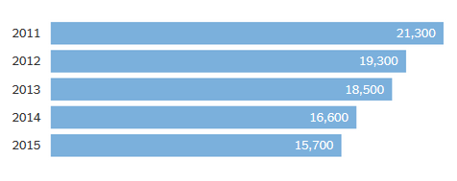

In December 2013, border security agents caught Clemente Armenta-Velasquez trying to return to the United States near Nogales, Ariz. After arriving in the United States in 2000, he had lived and worked in Arizona, where, records show, he was prosecuted on drug charges in 2002. He also served time in prison after being convicted of possession with intent to distribute marijuana, a felony, in 2010. He was deported the following year.

Mr. Armenta-Velasquez’s lawyer told a federal judge that his client, who had left school after fifth grade, had tried to come back to support his wife and three children in Mexico. “He couldn’t find a job in Mexico that would give a decent life for his family,” said the lawyer, Ricardo Bours, according to court papers.

Before sentencing Mr. Armenta-Velasquez to 57 months in prison, after which he will almost certainly be sent back to Mexico again, the judge suggested that Mr. Armenta-Velasquez might have been ordered deported as many as six times in the past.

“I knew I wasn’t supposed to” return, Mr. Armenta-Velasquez said in court. “I did it out of great need, but I apologize for that.”

On Valentine’s Day, Rogelio Ortiz stopped by the local immigration office in Charlotte, N.C., to update his family’s address. He was seeking asylum in the United States after arriving from Honduras last February, fleeing arms traffickers who threatened him after he asked them to stop storing weapons in his brother’s house.

Fifteen minutes later, an officer came out to tell Mr. Ortiz’s wife, Teresa, and daughter, Abigail, that he had been detained. Without realizing it, Mr. Ortiz, 49, had already lost his asylum case: He had been deported 14 years ago after a previous stint working in the United States, and was ineligible.

Since 2009, migrants seeking asylum from Mexico and Central America’s Northern Triangle region — Honduras, El Salvador and Guatemala — [have surged across the border](https://www.nytimes.com/2016/11/13/world/americas/fleeing-gangs-central-american-families-surge-toward-us.html) at a relentless pace, fleeing gang violence and poverty. Many of them are children traveling alone or women with children.

Nearly 409,000 migrants were caught trying to cross the United States’ southwestern border illegally in the 2016 fiscal year, an increase of 23 percent over the previous year, according to government statistics.

Many ask for asylum, but in most cases, the requests are denied. While they wait, a process that can take years to conclude, they are often released to move freely into the country.

That can mean disappearing beyond the reach of immigration officials. The system has infuriated those who advocate tougher enforcement, prompting the Trump administration to propose detaining asylum seekers at the border or forcing them to wait it out in Mexico.

“I know coming into the country illegally is a crime, but millions of people have done it, and now we come here asking for help,” Teresa said.

Now she seeks work to pay for a plane ticket. Teresa plans to renounce her own asylum claims to reunite, once again, with her husband — this time, back in Honduras.

Sources: Country of origin and crime data from the Migration Policy Institute. Unauthorized immigrants with children, years of duration and polling data from the Pew Research Center. Data on overstayers from the Center for Migration Studies. Illegal re-entry data from the United States Sentencing Commission.

Reporting was contributed by Jennifer Medina in Los Angeles, Lizette Alvarez in Miami and Meredith Hoffman in Austin, Tex.; Doris Burke contributed research.